Does your research involve:
- Genomics
- Pharmaceutics
- Medicine
- Molecular Biology

Are you trying to leverage:
- Human Genome
- Data Mining
- Scientific Literature
Then …
InPharmix
Incorporated
Has the tools & services you need!

- Leveraging the Scientific Literature in Bioinformatics Analysis
- Pharma Focused Bioinformatics Analysis
- Software and Database Solutions
- Custom Software Development
- Bioinformatics Consulting for the Pharmaceutical Industry

InPharmix
Incorporated
Founding Principles
The information content, size and
cost of the biomedical literature
dwarfs the human genome.
The cost of extracting information from
the human genome will dwarf the cost
of sequencing the human genome.
Leveraging the genomic data and literature together will lead to new drug targets and provide new insights into
the treatment of diseases.
The pharmaceutical industry has
specific bioinformatics needs that
are not being addressed by other
software providers.

InPharmix
Incorporated

Phone: (317) 422-1464
Web: www.InPharmix.com
Email: Info@InPharmix.com
PO Box 406
Greenwood, IN 46142

08/00 Copyright ©2000 InPharmix Incorporated.
All rights reserved

InPharmix
Incorporated

The Source for
Post-Genomic Era
Bioinformatics Solutions
for the
Pharmaceutical Industry
Unlocking the Promise

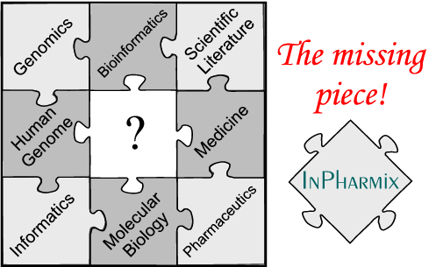

A good drug development candidate is worth tens or even hundreds of millions of dollars. Given the highly competitive nature of pharma research, it is critical that researchers fully exploit all available sources of information. However, as the human genome project approaches completion, pharmaceutical researchers are being swamped by data, in both the public and private domain. The multibillion-dollar worldwide investment in the human genome has generated tens of thousands of sequences. In addition, the scientific literature consists of over 7 million publications. InPharmix Incorporated is creating the tools required to effectively exploit this data explosion.

Company Overview
InPharmix Incorporated provides pharmaceutical and biotechnology researchers the tools necessary to maximize the value of public and proprietary genomic and scientific literature databases. InPharmix accomplishes this by offering clients the pharma focused bioinformatics and literature mining capabilities necessary for the genomic era.
Products offered by InPharmix include patented and proprietary bioinformatics and text mining software, custom application development, and bioinformatics consulting services specifically focused on the needs of the pharma researcher.

Products and Services
The software products developed by InPharmix can be divided into three main categories: Literature and text processing tools, Database search tools and Triage tools.

Literature and Text Processing Tools
Literature and text processing tools allow the researcher to leverage the genomic data and scientific literature together, thus creating a sum more valuable than the parts.

Database and Search Tools
Database and search tools include value added sub-classification of public databases providing search capabilities focused on the needs of the pharmaceutical researcher. These sub-database tools are also incorporated in the triage tools.

Triage Tools
Triage tools include automated analysis packages for single and multiple DNA and protein sequences. These tools are specifically focused at the needs of the pharmaceutical researcher and provide analysis particularly relevant to drug discovery.

Visit our website at:
http://www.InPharmix.com

Product List

StAT
Analyzes groups of related scientific abstracts. Quickly summarizes the important literature concerning a gene, protein, tissue, disease or drug. (available free of charge at the InPharmix web site)

PDQ_MED
Analyzes the literature concerning a set of genes related under an experimental paradigm. Rapidly identifies interrelationships between these genes. Specifically designed for the analysis of shotgun, differential display, subtracted libraries and gene chip studies.
(available Q3/2000)

Pharma_SeqDB
Pre-triaged, annotated and curated database of known drug targets suitable for BLAST searching. Provides a list of genes that you can quickly act upon without having to sift through hundreds of uninteresting genes.
(available Q4/2001)

Advanced Text Analysis
Uncover key information regarding signaling and metabolic pathways, disease physiology, pharmacology and more.
(available Q3/2001)

And Under Development …
Triage and pipeline tools for Signal Peptide, GPCR and Nuclear Receptor classifiers, Pharma specific motif libraries and more!

Do you have other ideas
or needs?
Give us a call; we will be glad to discuss solutions for your particular problem.

