Powerful analysis
of the
literature for connections within a set of
experimentally related genes

Pair-wise Data Query to MEDLINE (PDQ_MED)

Description:
Gene libraries provide a wealth of information on the genes expressed by a particular tissue. Frequently, many of the genes are known in the literature, but until now, no practical method for exploring the possible interconnections between the genes existed. PDQ_MED provides an effective tool for identifying and exploring the relationships between a set of genes. PDQ_MED exhaustively searches and analyses the more than 10 million records in MEDLINE for relationships between the set of genes under investigation. The analysis includes co-occurrence, proximity checking and weighting based on total term frequencies.

Use:
The researcher inputs a list of gene, tissue or disease terms, including alternate names and pseudonyms, and may restrict the search by language or date. Other MEDLINE search options are also supported, including title and author searches. In addition, the researcher may define a list of pharma terms.

Results:
PDQ_MED returns clustered groupings of the scientific literature, suggesting possible interactions and inter-relationships between the genes of the query list. Results are presented in graphical form, as highlighted sentences and as links back to the original literature.

Advantages:
PDQ_MED provides an analysis capability that is available nowhere else. It quickly identifies literature that suggests how a set of genes may be functionally related, with particular emphasis on pharma relevant concepts and relationships. PDQ_MED is indispensable for the analysis of shotgun, differential display and subtracted libraries as well as gene chip studies.

Ordering Information:
PDQ_MED is available for license from the InPharmix web site. Stand-alone versions (PC, Mac and UNIX) are also available. Contact InPharmix for pricing information.

(over)
Example:
As an example, we have analyzed a set of 50 known genes randomly selected from a liver EST library. MEDLINE contains nearly 50,000 abstracts for these 50 genes. This is an intractable quantity of data for traditional text browsing methods. A PDQ_MED analysis of this set of 50 genes identifies a subset of 16 genes which co-occur in the literature, suggesting a number of inter-relationships including regulatory, metabolic, and signaling pathways.
Tree Analysis:
PDQ_MED provides the user with a hierarchical tree analysis of the co-occurrence of the terms within a given set. In the tree below, closely related terms are connected in the hierarchy. The numbers in parenthesis represent the inverse of the degree of co-occurrence. Individual terms and term-pairs are linked back to the MEDLINE abstract.

ILGFBP4──(0.3 R)ILGFBP2──(0.5 R)ILGFBP3
│
├───────(1.7 R)TGIFP────(0.6 R)PROCOLLAGEN C!
│ │
│ └───────────(3.0 R)PITUITARY ADEN!
│
└───────(2.2 R)CATHEPSIN D─(1.4 R)PROGASTRICSIN
│
└───(2.2 R)ALPHA─1─ANTICH!─(1.0 R)ALPHA─2─MACROG!──────(1.9 R)BETA─2─MICROGL!
│
├─(2.3 R)LITHOSTATHINE───(2.3 R)COLIPASE───(0.9 R)EIF─3
│
└─(2.7 R)PHOSPHATIDYLIN!─(1.2 R)CD59
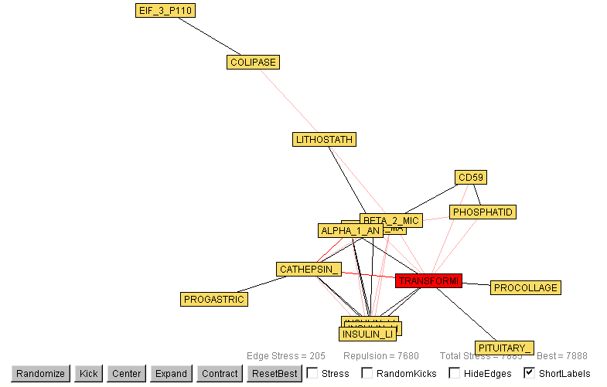
Graph Analysis:
PDQ_MED also provides a graphical analysis of the co-occurrence of the terms within the set. In the graph at right, the complete set of linkages between terms is shown. The lengths of the interconnecting lines represent the inverse of the frequency of co-occurrence.

Other Output:
Key Sentences (more than two query or pharma terms):
10753589 The results demonstrate that IGF-I regulates IGFBP-4 post-trancriptionally and post-translationally, whereas IGFBP-3 is only affected post-translationally.
Pharma Sentences (query plus a pharma term):
10389993 Cytosolic determinations of cathepsin-D (cath-D), urokinase plasminogen activator (uPA) and its specific inhibitor PAI-1 have shown an association with adverse prognosis in breast cancer.
Proximity Sentences (two query terms):
7538844 The chymotryptic activity of PSA was further confirmed by the ability of alpha-1-antichymotrypsin and chymostatin to block PSA cleavage of radiolabeled IGFBP-3.
For the full output for this example, visit http://InPharmix.com/PDQ_MED_example.htm

